**EXPERIMENT -2**

**Objective:** To prepare a class diagram for :

1. Library Management System
2. Railway Management System
3. Hospital Management System

**Hardware/ Software Requirements:** Star UML

**Theory:** Class diagram is a static diagram. It represents the static view of an application. Class diagram is not only used for visualizing, describing, and documenting different aspects of a system but also for constructing executable code of the software application. Class diagram describes the attributes and operations of a class and also the constraints imposed on the system. The class diagrams are widely used in the modeling of object oriented systems because they are the only UML diagrams, which can be mapped directly with object-oriented languages.

1. **Library Management System**

**Diagram:**

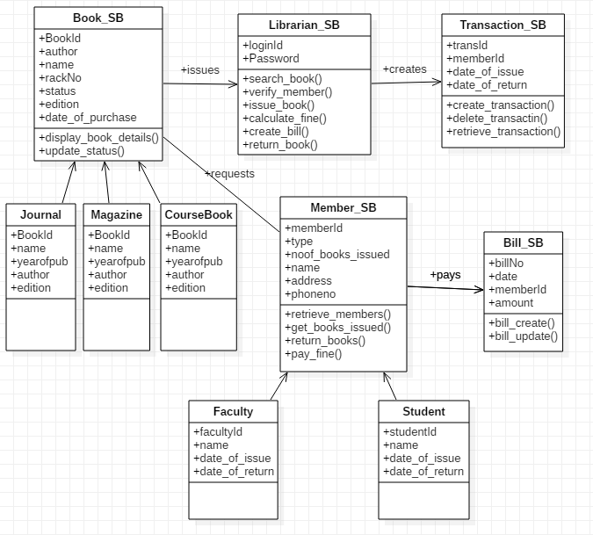

**DESCRIPTION:**

1. **Book**
2. **Attributes**
3. bookId- Identification of book
4. author – Author of Book
5. name – name of book
6. rackno- rack number of Book
7. status – Status of book availability
8. edition – book edition is up to date
9. date of purchase – book purchasing date
10. **Operation**

i. displaybookdetails – It will display the details of the book

ii. updatestatus – Is the book is available in Library or not.

1. **Librarian**
2. **Attributes**
3. loginId – It will login through the login id of the librarian into his/her account.
4. password - Each librarian will have specific password for his/her account.
5. **Operation**
6. searchbook – Librarian will search the specific book in the library.
7. verifymember – Librarian will verify its member by cross checking its data.
8. issuebook – Librarian will issue the specific book to the member.
9. calculatefine - Librarian will calculate the fine of member who has submitted late and collect it at the end.
10. createbill – Librarian will create bill of purchasing book and also create bill of fine.
11. returnbook – Member will return book to librarian.
12. **Transaction**
13. **Attribute**
14. transId – This is provided by the server when the member will make transaction of book item.
15. memberid – Member will have its specific id from which he/she can make transaction.
16. dateofIssue – Its will show the date in which the transaction is made by the member.
17. duereturn – It is the amount which is due on the member when they made the transaction.
18. **Operations**
19. createTrans – It will help to make or start the transaction of the book.
20. deleteTrans – It will help us to delete the transaction.
21. retrieveTrans – It will help us to retrieve the specific transaction.
22. **Member**
23. **Attribute**
24. memberId- Member will have its specific id from which he/she can make transaction or request books.
25. type- It is that which tell whether the member is Faculty or Student.
26. noofBookIssued – It shows how many book is issued by the member.
27. name – It will show the name of the member.
28. address – It will show the address of the member.
29. phoneno -It will show the phone number of the member.
30. **Operations**
31. retrieveMember – It will help us to retrieve the member like Faculty and Student.
32. getBookIssued – It will help member to issue the specific book from the library.
33. retrunBook- It will help member to return book to Librarian.
34. payFine- It will help member to pay the fine of Book to Librarian.
35. **Bill**
36. **Attribute**
37. billNo – It will help to get bill no of transaction.
38. date – It will provide the date of bill generated.
39. memberId – It will help each specific member to make their own bill.
40. amount – It shows actual the amount of book or fine amount.
41. **Opertaions**
42. billcreate- It will help member to create the bill for transaction.
43. billupdate- It will help member to update the bill .
44. **Railway Management System**

**Diagram:**

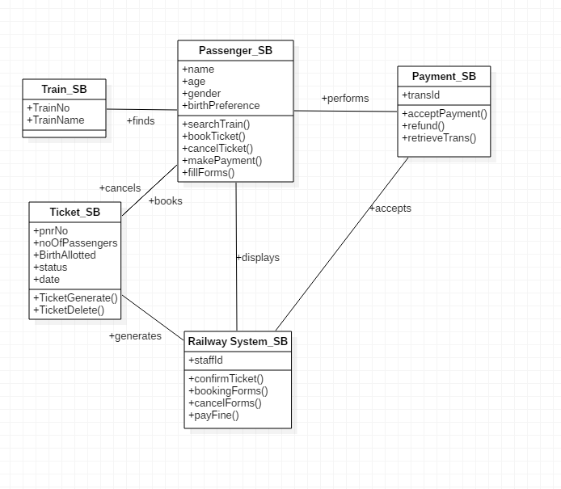

**DESCRIPTION:**

**1.Passenger**

**a. Attributes**

1. name- Name of the passenger.
2. age- Age of the passenger.
3. gender- Gender of the passenger.
4. birthPreference- Preference of the birth passenger wants.

**b.Operations**

1. searchTrain- The passenger finds the trains in the railway system.
2. bookTicket- The passenger books the train.
3. cancelTicket- The passenger cancels the train.
4. makePayment-The passenger makes payment for the booked train.
5. fillForm- The passenger fills form for booking ticket.

**2. Ticket**

**a. Attributes**

1. pnrNo- Pnr no. of the booked ticket.
2. noOfPassengers- Total no. of passengers travelling on the train.
3. birthAllotted- The births allotted to the passengers.
4. status- The status of the ticket, whether it is confirmed or waiting.
5. Date- The date of travel on the booked ticket.

**b. Operations**

1. ticketGenerate- The confirmed ticket is generated for the passenger.
2. ticketDelete- The booking of ticket is deleted when it is cancelled by passenger.

**3. Train**

**a. Attributes**

1. trainName- Name of the train.
2. trainNo- Number of the train.

**4. Payment**

**a. Attributes**

i. transId- The transaction id generated after payment.0

**b. Operations**

1. acceptPayment- The payment of the user is accepted for booking.
2. refund- The refund of cancelled ticket is sent to the passenger.
3. retrieveTrans- The information reagarding transaction is retrieved.

**5. Railway System**

**a. Attributes**

1. staffId- The id of the staff of railway.

**b. Operations**

1. confirmTicket- The booked ticket is confirmed by the system.
2. bookingForm- The form for booking a ticket is generated.
3. cancelForm- The form for cancelling a ticket is generated.
4. payFine- The fine for ticket cancellation is collected
5. **Hospital Management System**

**Diagram:**

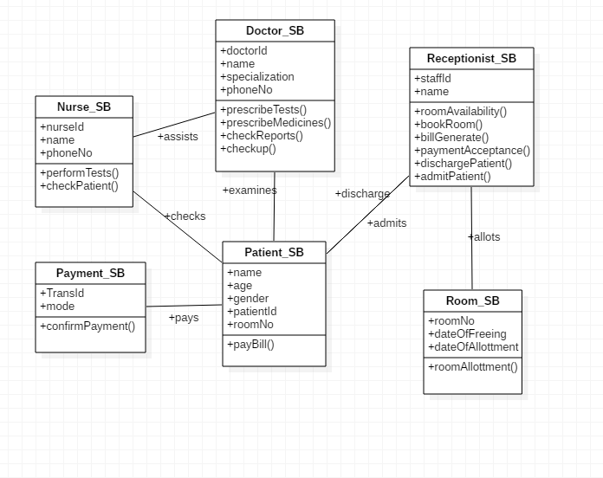

**DESCRIPTION:**

1. **Doctor**
2. **Attributes**
3. doctorId- Id of the doctor
4. name- Name of the doctor
5. specialization- The specialization of the doctor
6. phoneNo- The contact number of the doctor
7. **Operation**
8. prescribeTests- The doctor prescribes the tests to the patient.
9. prescribeMedicines- The doctor prescribes the medicines to the patient
10. checkReports- The reports of the patient is checked by the doctor.
11. checkup- The doctor is called to do the checkup of the patient.
12. **Receptionist**
13. **Attributes**
14. staffId- The Id of the staff member.
15. name- The name of the staff member.
16. **Operation**
17. roomAvailability- The operation is used to check the availability of the rooms.
18. bookRoom- The operation is used for booking a room in the hospital.
19. billGenerate- The operation is used to generate the bill for the patient.
20. paymentAcceptance- The operation is used to accept the payment from patient
21. dischargePatient- The operation is used to check when patient can be discharged
22. admitPatient- The operation is used to admit a patient in hospital.
23. **Nurse**
24. **Attributes**
25. nurseId- The Id of the nurse.
26. name- The name of the nurse.
27. phoneNo- The phone number of the nurse.
28. **Operation**
29. performTests- The operation is used to perform Tests of patients.
30. checkPatient- The operation is used to check the patient periodically.
31. **Patient**
32. **Attributes**
33. name- The name of the patient.
34. age- The age of the patient.
35. gender- The gender of the patient.
36. patientId- The Id assigned to the patient.
37. roomNo- The roomNo of the patient.
38. **Operation**
39. payBill- The operation is used by the patients to make bill payments.
40. **Payment**
41. **Attributes**
42. transId- The transaction Id generated during payment.
43. mode- The mode through which the payment is made.
44. **Operation**
45. confirmPayment- The operation is used to check and confirm the payment.
46. **Room**
47. **Attributes**
48. roomNo- The number of the room that are allotted and free.
49. dateOfFreeing- The date on which a room becomes free/vacant.
50. dateOfAllottment- The date on which the room is allotted.
51. **Operation**
52. roomAllottment- The operation to allot a particular room to the patient.